# **Name: Abdurrahman Qureshi**

# **Roll No: 210451**

**--- JPR HW ---**

**1) WAP in JAVA which will print sum and reverse of ‘n’ digits number.**

**CODE:**

import java.util.Scanner;

public class JPRHWsumNRev

{

public static void main(String[] args)

{

Scanner userEnteredInt = new Scanner(System.in);

System.out.print("Enter Number: ");

int num, rem;

int rev = 0, sum = 0;

num = userEnteredInt.nextInt();

do {

rem = num % 10;

rev = rev * 10 + rem;

sum = sum + rem;

num = num / 10;

}

while (num > 0);

System.out.println("Reverse of given number: "

+ rev);

System.out.println("Sum of digits of given number: "

+ sum);

}

}

**OUTPUT:**

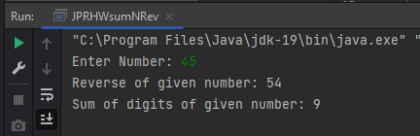

**2) WAP in JAVA which will print factorial of a number.**

**CODE:**

import java.util.Scanner;

public class Main {

public static void main(String[] args){

Scanner sc = new Scanner(System.in);

System.out.print("Enter Number: ");

int ogNum = sc.nextInt();

int fact = 1;

int num = ogNum;

while (num != 0) {

fact = fact * num;

num = num - 1;

}

System.out.println("Factorial : " + ogNum + "! = " + fact);

}

}

**OUTPUT:**

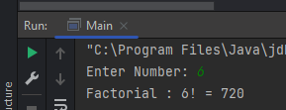

**3)WAP in JAVA which will print Factorial series of a number from 1 to n**

**CODE:**

import java.util.Scanner;

public class Main {

public static void main(String[] args){

Scanner sc = new Scanner(System.in);

System.out.print("Enter Range of Factorial Series: ");

int n = sc.nextInt();

int fact = 1;

int num = 0;

System.out.println();

System.out.println("Factorial Series: ");

for (int i = 1; i <= n; i++) {

fact = 1;

num = i;

while (num != 0) {

fact = fact * num;

num = num - 1;

}

System.out.println(i + "! : " + fact + " ");

}

}

}

**OUTPUT:**

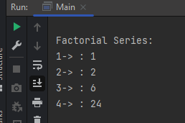

**4) WAP in JAVA Which will print Armstrong numbers between 1 to 500**

**CODE:**

class Main

{

public static void main(String[] arg)

{

int i=100,arm;

System.out.println("Armstrong numbers between 100 to 999");

while(i<1000)

{

arm=armstrongOrNot(i);

if(arm==i)

System.out.println(i);

i++;

}

}

static int armstrongOrNot(int num)

{

int x,a=0;

while(num!=0)

{

x=num%10;

a=a+(x*x*x);

num/=10 ;

}

return a;

}

}

**OUTPUT:**

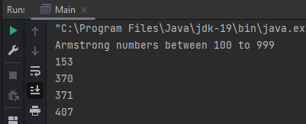

**5) WAP in JAVA Which will calculate GCD and LCM**

**CODE:**

import java.util.Scanner;

public class Main {

public static void main(String[] args) {

Scanner input = new Scanner(System.in);

System.out.print("Enter the First Number: ");

int num1 = input.nextInt();

System.out.print("Enter the Second Number: ");

int num2 = input.nextInt();

int gcd = 0;

for (int i = 1; i <= num1 && i <= num2; i++) {

if (num1 % i == 0 && num2 % i == 0) {

gcd = i;

}

}

int lcm = (num1 * num2) / gcd;

System.out.println("GCD of " + num1 + " and " + num2 + " is " + gcd);

System.out.println("LCM of " + num1 + " and " + num2 + " is " + lcm);

}

}

**OUTPUT:**

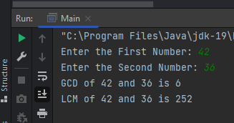

**6) WAP in JAVA Which will print prime from 1 to n**

**CODE:**

import java.util.Scanner;

public class Main {

public static void main(String[] args) {

Scanner sc = new Scanner(System.in);

System.out.print("Enter Range : ");

int n = sc.nextInt();

int count = 0;

System.out.print("Prime Series : ");

for (int i = 1; i <= n; i++) {

count = 0;

for (int j = 1; j<= i; j++) {

if (i%j == 0) {

count++;

}

}

if (count == 2) {

System.out.print(i + " ");

}

}

}

}

**OUTPUT:**

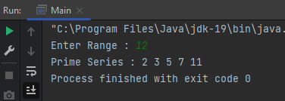

**7) WAP in JAVA Which to check prime or not**

**CODE:**

import java.util.Scanner;

public class Main {

public static void main(String[] args) {

Scanner sc = new Scanner(System.in);

System.out.print("Enter Number : ");

int num = sc.nextInt();

int count = 0;

for (int i = 1; i<= num; i++) {

if (num%i == 0) {

count++;

}

}

if (count == 2) {

System.out.println(num + " is a Prime Number");

} else {

System.out.println(num + " is not a Prime Number");

}

}

}

**OUTPUT:**

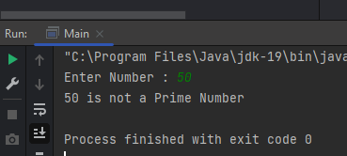

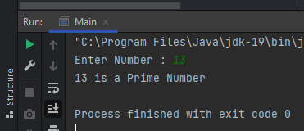

**8) WAP in JAVA Which to print Fibonacci from 1 to n**

**CODE:**

import java.util.Scanner;

public class Main {

public static void main(String[] args) {

Scanner sc = new Scanner(System.in);

System.out.print("Enter Range : ");

int range = sc.nextInt();

long f1 = 0L;

long f2 = 1L;

long f3;

System.out.print("Fibonacci Series : " + f1 + " " + f2);

for (int i = 0; i <= range; i++) {

f3 = f1 + f2;

System.out.print(" " + f3);

f1 = f2;

f2 = f3;

}

}

}

**OUTPUT:**

